Documentation on my project

Project name: Certificate Generator

Name: Iswariya M

College name: Sri Venkateswara college of Engineering

Code:

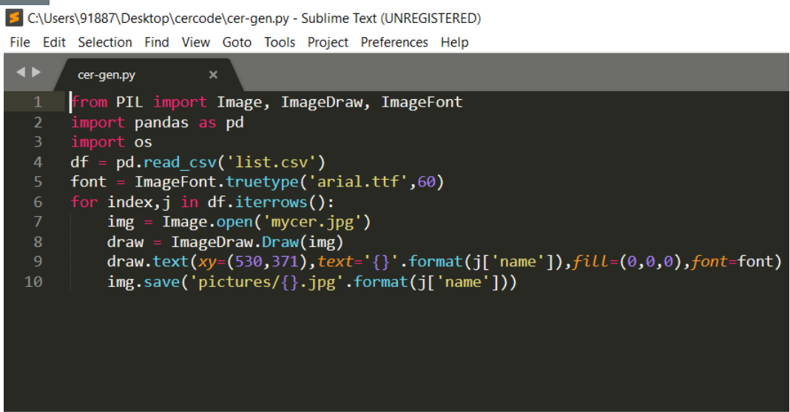

* First I have created list of names in csv file format which is going to be printed in certificate.
* Then I created my certificate template consists of my name as head instructor and content of my certificate in filename.jpg format.
* Then I installed python libraries PIL,pandas,os,pillow.
* Then finally coming to the coding part,

I imported the packages and I gave access to my csv file so that it will fetch names from it.

* Then set the file fonts and coordinates so that name is placed in the correct place in the certificates.
* I called some functions such as Image.open(jpg file),ImageDraw.Draw(img).
* Then I saved the generated certificates in separate folder.

Excel sheet content:

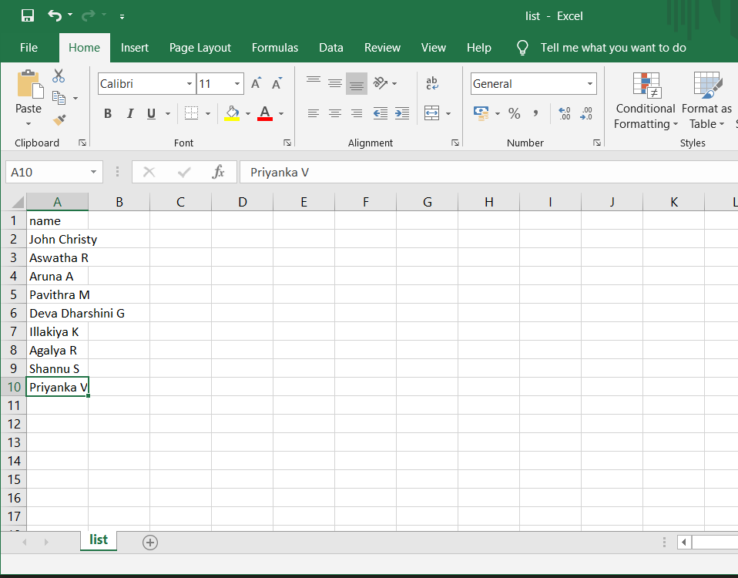

These are the names of the students which the certificate is generated.

My certificate Template

* Template Consists of my name as head instructor
* And content of certificate except the name of candidate to which certificate is issued.

Code execution:

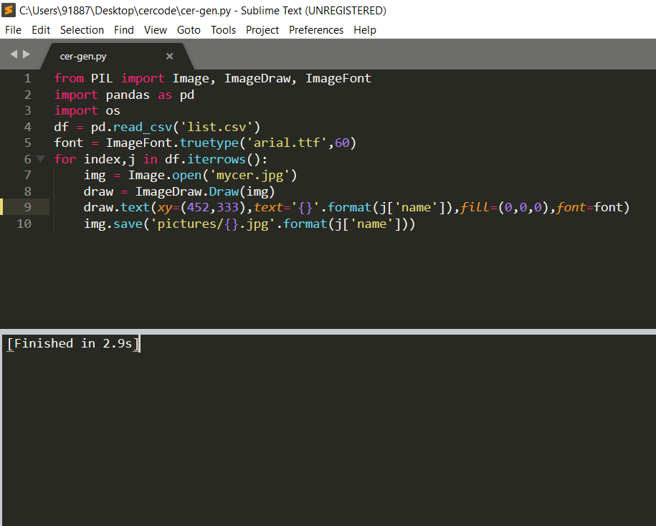

Code is successfully executed.

Output:

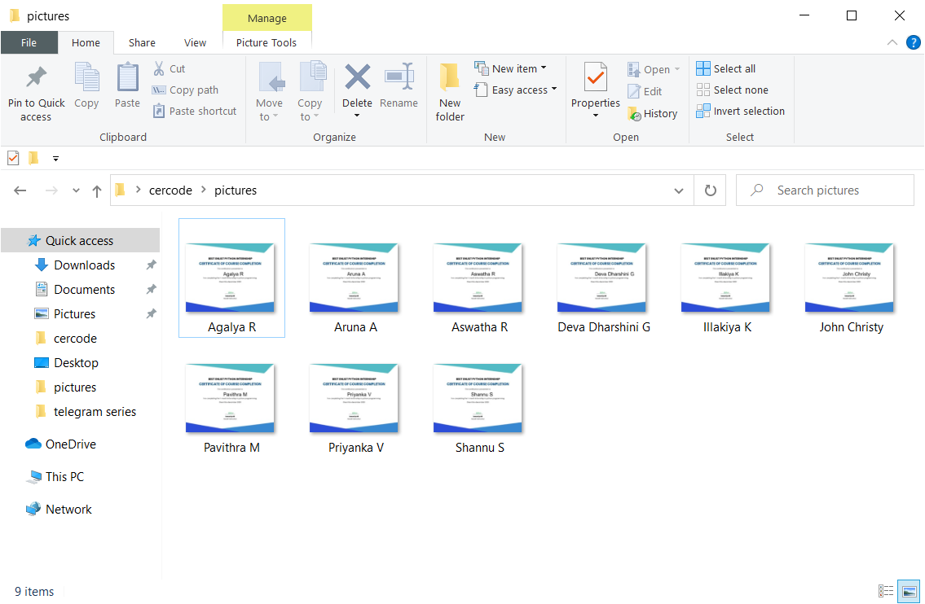

Certificates are generatored successfully.

Sample output certificate:

